**Powertrain II (ME 548) Project**

**Simulation and Analysis of Shift Processes of a 6-speed FWD AT**

**Name: Xiaohui Luo**

**UMID: 50585412**

**Date: April 1,2017**

**Contents**

Introduction……………………………………………………3

Objective………………………………………………………3

Vehicle Selected Parameter…………………………………...4

Calculation Process……………………………………………7

Simulink Model Building…………………………………….12

Modeling Result………………………………………………16

Conclusion…………………………………………………….18

Appendix………………………………………………...…….19

**Introduction**

Nowadays most of the automotive vehicles are equipped with the automatic transmission. The shift process auto transmission is controlled by the hydraulic pressure and the relative electronic control elements. On the purpose of having a smooth shift process, the pressure of oncoming and off going clutch should be carefully controlled.

**Objective**

The objective of the project is to simulate and analyze the fixed gear operations and shift processes of a 6-speed FWD AT (shown on the next page) with a final drive ratio of 2.6. The following tasks must be completed for the project:

1. Select the data for a midsize car needed for the project, including the dimensional and weight data, engine data, torque converter data, tire dimension, mass moments of inertia, etc.
2. Establish the mathematic model for the transmission-vehicle system, i.e., the general state variable equation, specific state variable equation, initial conditions, etc., for the 1st gear operation, the 1-2 shift, and the 2nd gear operation.
3. Solve the state variables by hand in terms of input variables and control variables for the 1st gear operation, the 1-2 shift, and the 2nd gear operation.
4. Use the formulation in c) to simulate the launch of the vehicle from rest in 1st gear, a 1-2 shift initiated at a speed of 15 mph, and 2nd gear operation for 2 second after the 1-2 shift with an open torque converter and a fixed throttle position.

You need to optimize the clutch torque profiles for shift quality. As the output, you need to provide the following plots:

* Engine torque V.s Time
* Transmission input torque V.s Time
* Transmission Output torque V.s. Time
* Clutch Torque Profiles V.s Time
* Engine RPM V. s. Time
* Transmission input and output angular velocities in RPM Vs. time
* Angular velocities of sun S1 and carrier C1 in RPM V.s. Time
* Vehicle speed and acceleration V.s. Time

**Vehicle Selected Parameter**

**(1) Engine:**

Engine Torque Verse Engine Speed with 100% throttle open



**(2) Torque Converter:**

Converter Torque ratio plot:



Capacity factor plot:



**(3) Transmission:**

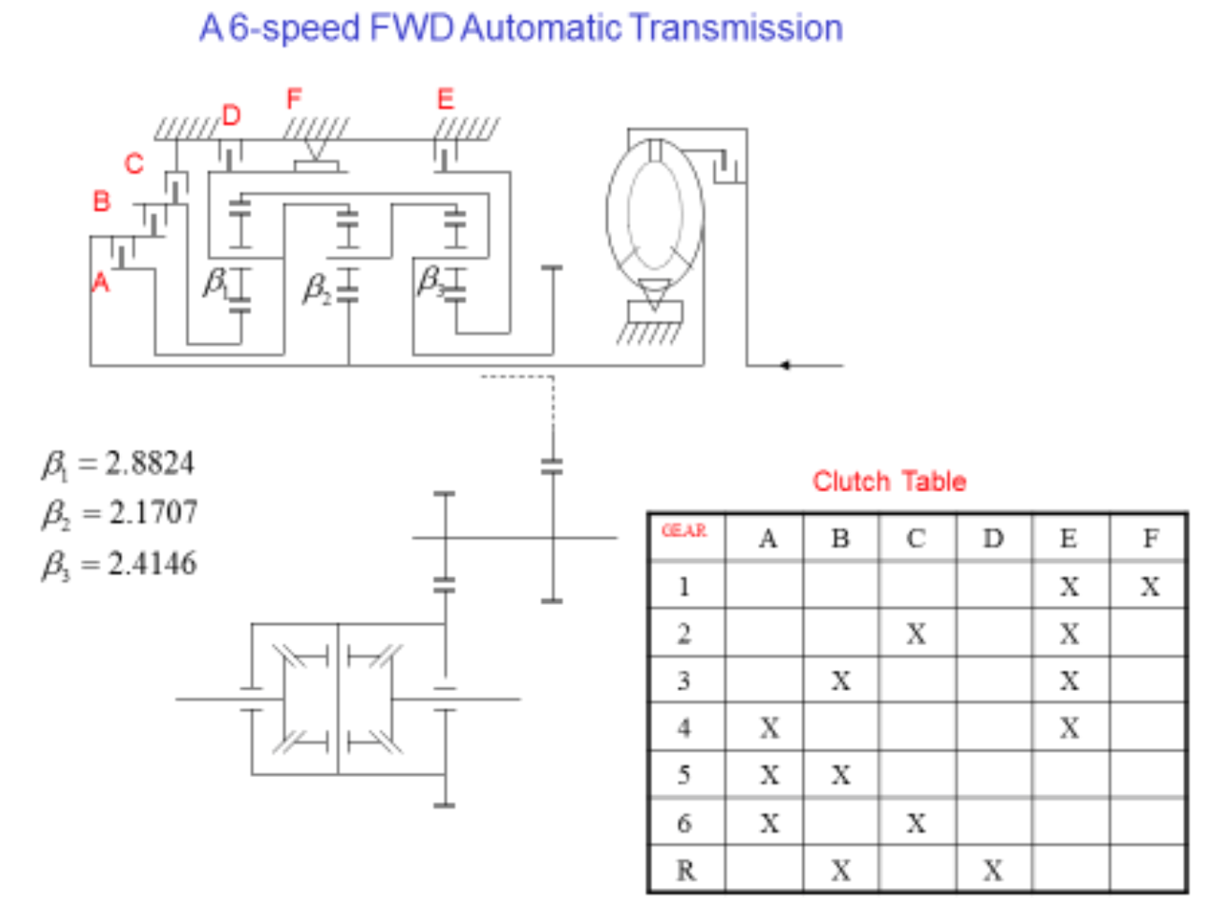

**(4) Others:**

|  |  |
| --- | --- |
| Vehicle frontal area | 29.46 ft2 |
| Air drag coefficient | 0.27 |
| Vehicle Weight | 3472 lbs |
| Rolling coefficient | 0.018 |
| Tire radius | 0.75 ft |
| Final ratio | 2.6 |
| Moment of inertia of Assembly C1R2 | 0.02 lb. ft2 |
| Moment of inertia of Assembly C2R3 | 0.02 lb. ft2 |
| Moment of inertia of Assembly S1 | 0.02 lb. ft2 |
| Moment of inertia of Assembly S3 | 0.02 lb. ft2 |
| Moment of inertia of Assembly Input | 0.02 lb. ft2 |
| Moment of inertia of Assembly Output | 0.02 lb. ft2 |
| Moment of inertia of Assembly Engine and impeller | 0.3 lb. ft2 |

**Hand-Calculation Process:**

* **General state variable equations:**

Represent the general state variable equations in matrix form:

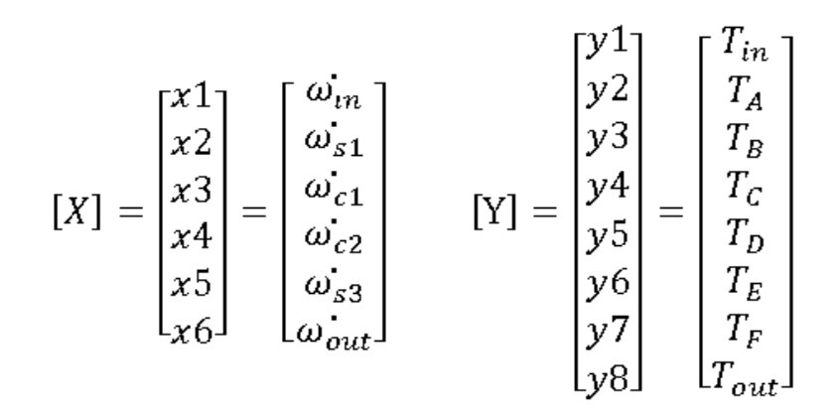

The equations above can be represented in the following matrix form:

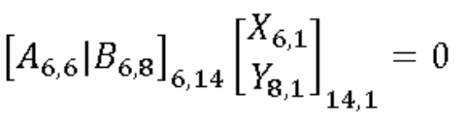

Where:

* **Specific state variable equations:**
* For the **first fixed** gear:

Clutches E and F are fully applied, so that the constraints caused by the engagement of clutches E and F are:

The specific state equation for first gear in matrix form:

Where,

;

Simplify the specific equation by variable elimination combining with TA = TB = TC= TD =0:

* For the **torque phase** of 1-2 shift:

Clutches E and F are fully applied. TC is control variable instead of zero. The constraints caused by the engagement of clutches E and F are:

The specific state equation for first gear in matrix form:

Where,

;

Simplify the specific equation by variable elimination combining with TA = TB = TD =0:

* For the **inertia phase** of 1-2 shift:

Clutch F overruns. TC and TF are control variables. Since clutch F is one-way clutch, TF =0. The constraint caused by the engagement of clutches E is:

The specific state equation for first gear in matrix form:

Where,

;

Simplify the specific equation by variable elimination combining with TA = TB = TD =0:

* For the **second fixed gear**:

Clutches E and C are fully applied, so that the constraints caused by the engagement of clutches E and F are:

The specific state equation for first gear in matrix form:

Where,

;

Simplify the specific equation by variable elimination combining with TA = TB = TD = TF =0:

**Simulink model building:**

**Block structure as reference:**

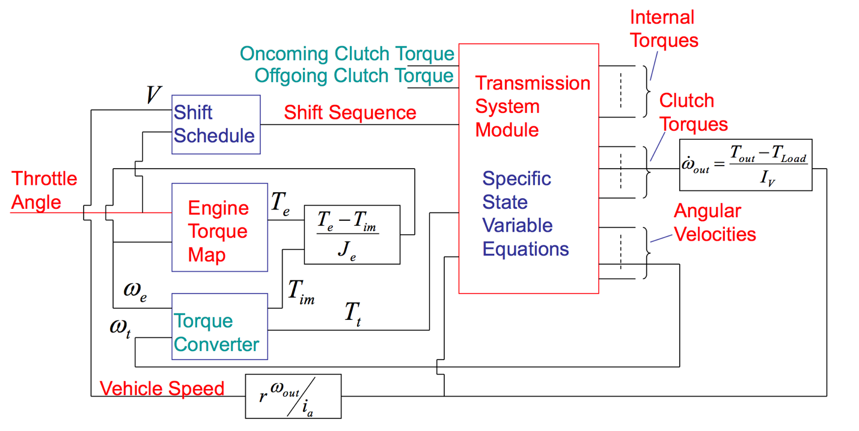

**(1) Engine:**

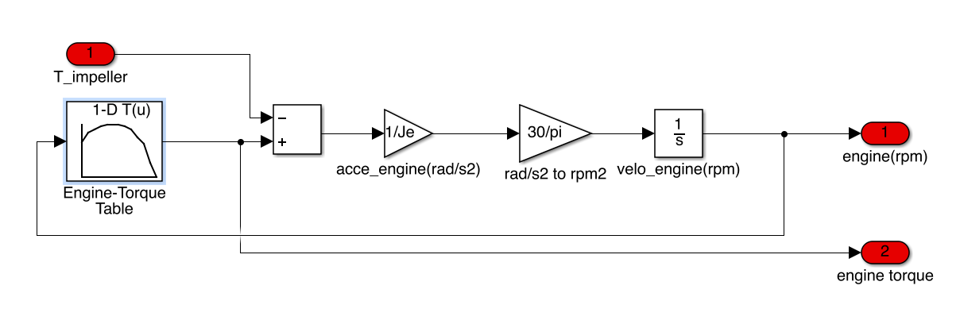

Equations:

Newton second law:

Conversion from rad/s to RPM: RPM=

**(2) Torque Converter:**

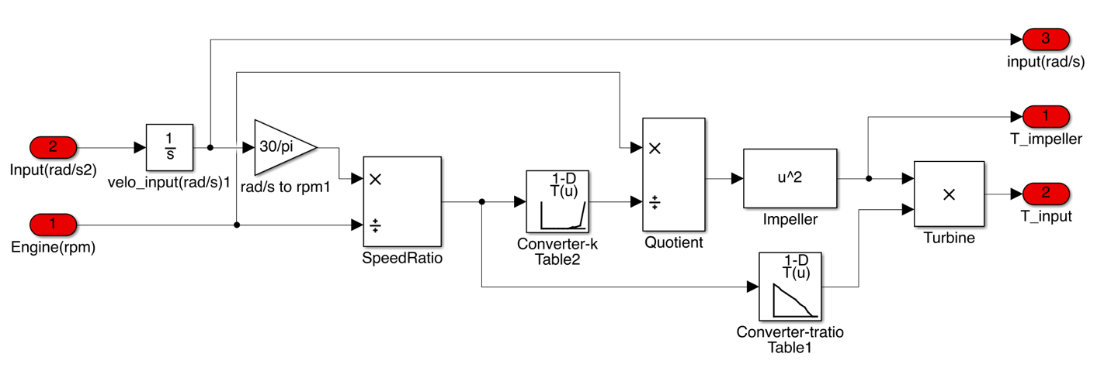

Equations:

**(3) Vehicle Dynamic:**

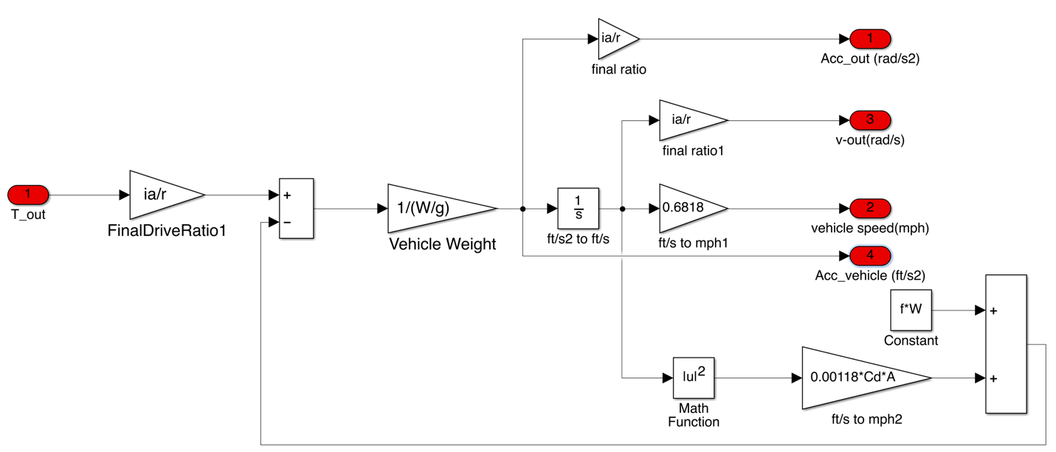

Equations:

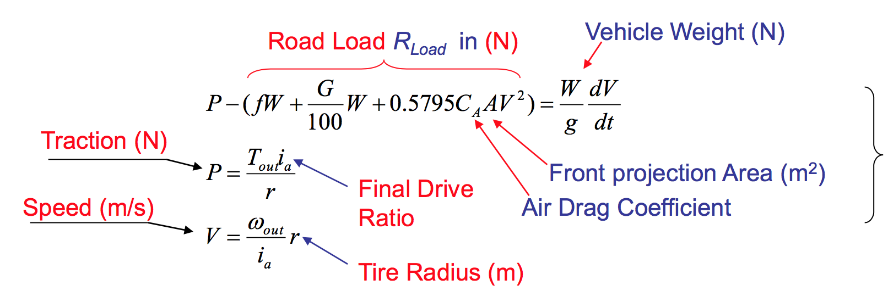

**(4) Shift logic:**

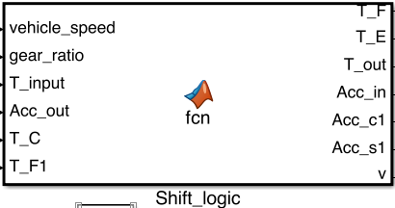

The detail of this Matlab function is on the **Appendix**. The process of Shift logic is based on following conditions to determine:

* From 1st fixed gear to Torque Phase: vehicle speed (mph) > 15mph
* From Torque Phase to Inertia Phase: off-going clutch TF =0
* From Inertia Phase to 2nd fixed gear: gear ratio = i2

**(5) Assembly model in Simulink:**

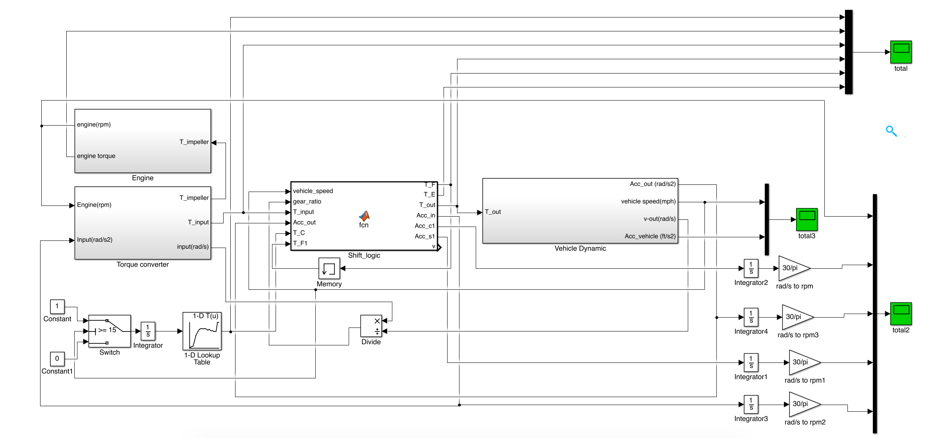

**Modeling Results:**

**(1)**

**Engine torque V.s Time**

**Transmission input torque V.s Time**

**Transmission Output torque V.s. Time**

**Clutch Torque Profiles (TF, TE, TC V.s Time)**

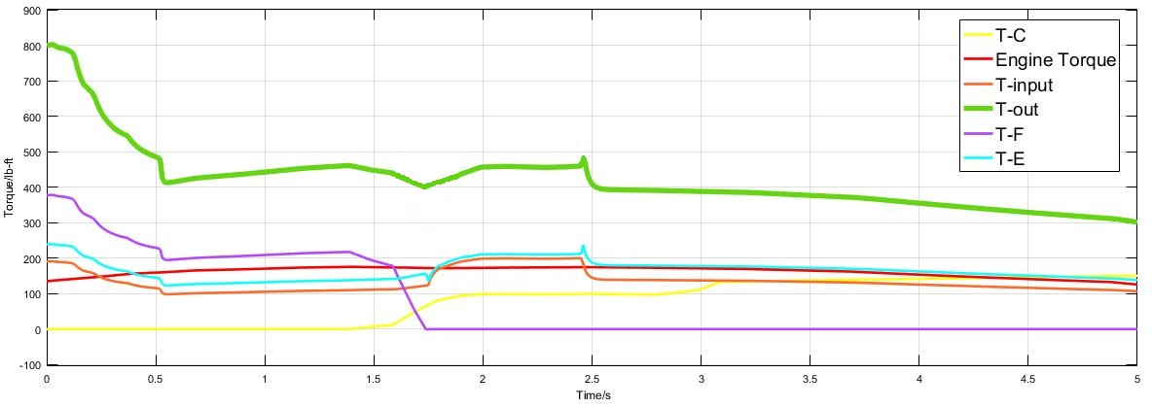

**（2）**

**Engine RPM V. s. Time**

**Transmission input and output angular velocities in RPM Vs. time**

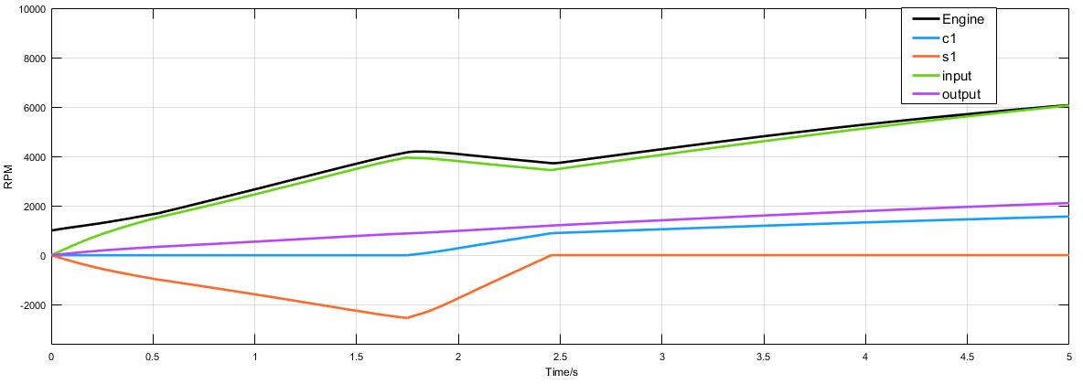

（3）**Vehicle speed and acceleration V.s. Time**

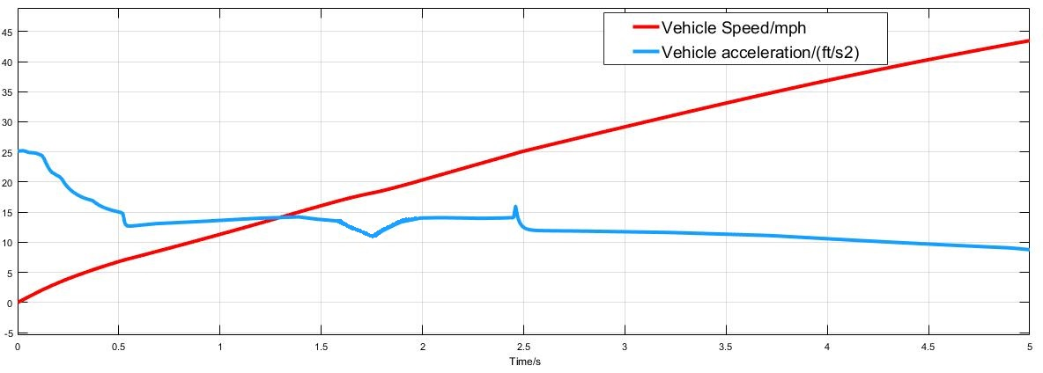

**Conclusion**

In this model, the shift process beginning from 1.5s takes almost 1 second, in which the torque phase costs 0.3 second. During the process of shifting, for the output torque plot, there exists the hole in the torque phase and overshoot in the inertia phase. After adjusting the profile of oncoming clutch TC, the hole and overshoot has been greatly improved so that the shift process is made to be more smooth. Additionally, the engine speed will reduce from 4150 RPM to 3800 RPM during shift process.

During this project, I have learned a lot and got more familiar with the relative knowledge of the powertrain. In order to get a reasonable result, calculation of the specific variable equations has to be careful enough to guarantee the shift logic is perfectly correct since it is the key thing to determine the values of torque and angular acceleration. Besides, the prescribed values for the moment of inertia are also so significant that it will affect the whole components of clutch torque and angular velocity from the specific variable equations.

This project let me not only have a good understanding of principle of powertrain, but also give me a good experience of utilizing Simulink software and debugging.

**Appendix:**

function [T_F,T_E,T_out,Acc_in,Acc_c1,Acc_s1,v] = fcn(vehicle_speed,gear_ratio,T_input,Acc_out,T_C,T_F1)

i1=1/0.223;

i2=2.8722;

I_input=0.02;

I_c2r3=0.02;

I_s1=0.02;

I_s3=0.02;

I_c1r2=0.02;

I_out=0.02;

T_F=0;

T_E=0;

T_out=0;

Acc_in=0;

Acc_c1=0;

Acc_s1=0;

v=0;

if (vehicle_speed<15)

Acc_in=Acc_out/0.223;

T_out=4.4837*T_input-4.4837*I_input*Acc_in-0.4459*I_c2r3*Acc_in-1.8528*I_s1*Acc_in-0.223*I_out*Acc_in;

T_F=2.1707*T_input-2.1707*I_input*Acc_in-2.4956*I_s1*Acc_in;

T_E=1.3131*T_input-1.3131*I_input*Acc_in-0.1306*I_c2r3*Acc_in;

Acc_s1=-0.6428*Acc_in;

Acc_c1=0;

else if (vehicle_speed>=15&&T_F1>0)

Acc_in=Acc_out/0.223;

T_out=4.4837*T_input-4.4837*I_input*Acc_in-0.4459*I_c2r3*Acc_in-2.8824*T_C-1.8528*I_s1*Acc_in-0.223*I_out*Acc_in;

T_F=2.1707*T_input-2.1707*I_input*Acc_in-2.4956*I_s1*Acc_in-3.8824*T_C;

T_E=1.3131*T_input-1.3131*I_input*Acc_in-0.1306*I_c2r3*Acc_in;

Acc_s1=-0.6428*Acc_in;

Acc_c1=0;

v=3;

else if (vehicle_speed>15&&gear_ratio>i2&&T_F1<=0)

a=0.8*T_input;

Acc_in=(Acc_out*(2.0656*I_c1r2+19.9443*I_s1)-3.8824*T_C+2.1707*a)/(0.4607*I_c1r2+6.9441*I_s1+2.1707*I_input);

T_out=4.4838*a-4.4838*I_input*Acc_in-1.9997*I_c2r3*Acc_out-2.8824*T_C+14.8072*I_s1*Acc_out-5.1555*I_s1*Acc_in-I_out*Acc_out;

T_E=1.3131*a-1.3131*I_input*Acc_in-0.5856*I_c2r3*Acc_out;

Acc_c1=2.0656*Acc_out-0.4607*Acc_in;

Acc_s1=5.1371*Acc_out-1.7886*Acc_in;

T_F=0;

v=2;

else if(vehicle_speed>15&&gear_ratio<=i2)

Acc_in=2.8722*Acc_out;

c=0.5591*T_input-1.6059*I_input*Acc_out+0.1912*I_c1r2*Acc_out;

T_E=1.3131*T_input-3.7716*I_input*Acc_out+0.5856*I_c2r3*Acc_out;

T_out=3.4146*T_E-2.8824*c-I_out*Acc_out;

Acc_c1=0.7424*Acc_out;

Acc_c2=1.4141*Acc_out;

Acc_s1=0;

T_F=0;

v=0;

end

end

end

end